Tutorial 1 – SDLC & STLC Phases
Screenshot Report
Field | Details
Website / Tool | GitHub (sign-in and sign-up pages)
URL | https://github.com/login
Module | Login / Sign-up / Logout
Student Task | Study the Login and Sign-up module, execute 6 test cases (TC01-TC06) with screenshots, and prepare an SDLC/STLC diagram showing where each testing activity occurs.
Test Cases | Same TC IDs as the test case sheet: TC01 to TC06
Tester Name | Tester: Kothari Mann Jitendrakumar
Enrollment No | 2504030100433
Environment | Windows 10/11, Google Chrome (latest), internet connection

Test Case Execution

TC01 – Verify Login page is accessible
TC ID | TC01
Test Case | Verify Login page is accessible
Test Data | URL: https://github.com/login
Expected Result | 'Sign in to GitHub' page opens with the login form
Actual Result | 'Sign in to GitHub' page opened with username/email and password fields
Status | PASS
Screenshot | 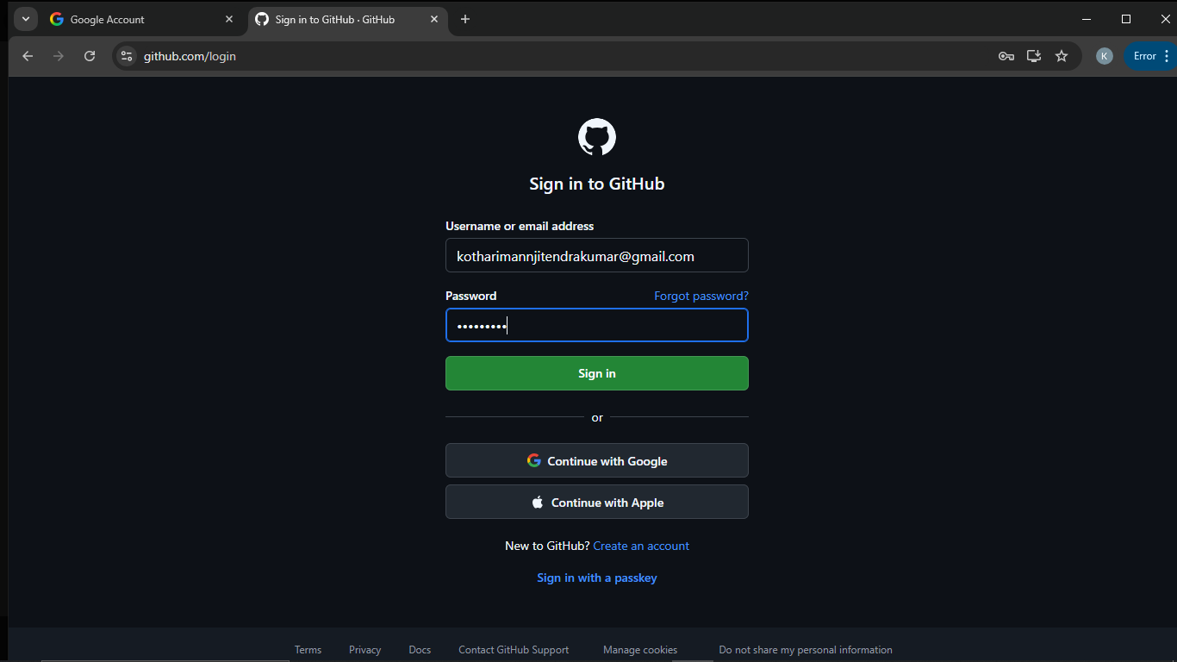
Defect ID | N/A

TC02 – Verify Signup page is accessible
TC ID | TC02
Test Case | Verify Signup page is accessible
Test Data | URL: https://github.com/signup
Expected Result | Sign-up page opens and asks for the email address
Actual Result | Sign-up page opened and asked for email
Status | PASS
Screenshot | 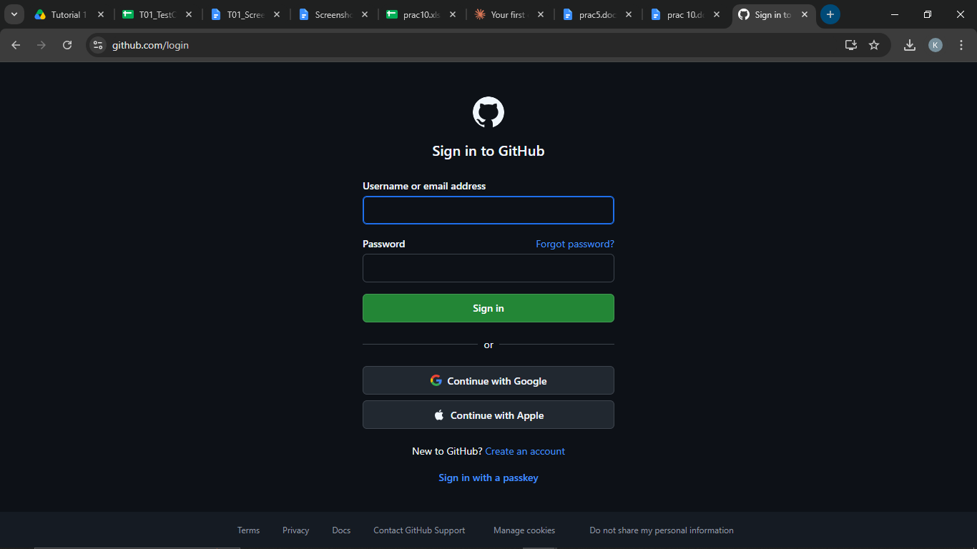
Defect ID | N/A

TC03 – Verify email field is available
TC ID | TC03
Test Case | Verify email field is available
Test Data | Field: 'Username or email address'
Expected Result | A 'Username or email address' field is visible and accepts typed text
Actual Result | 'Username or email address' field available; the e-mail address could be typed
Status | PASS
Screenshot | 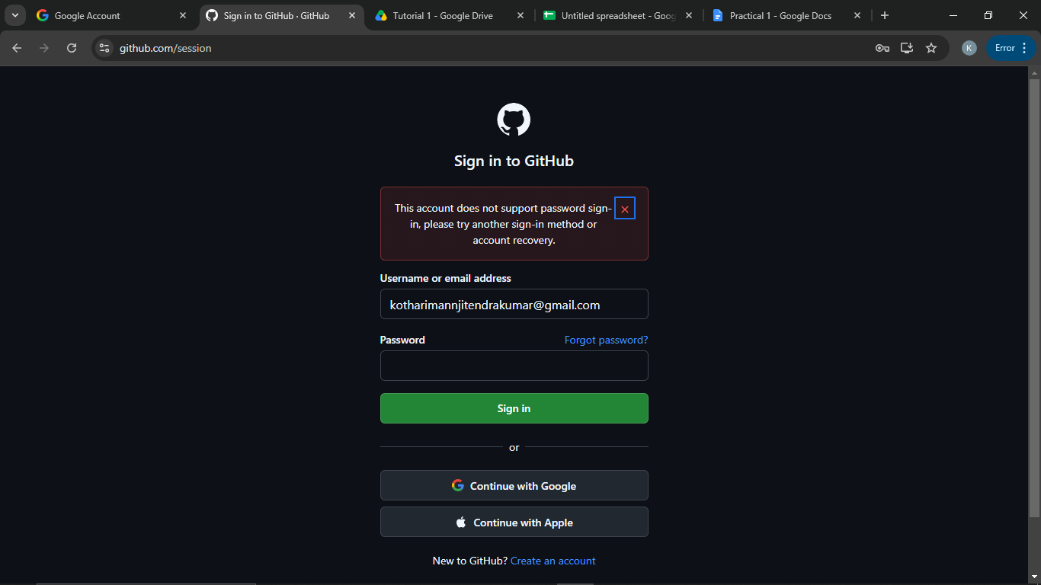
Defect ID | N/A

TC04 – Verify password field is available
TC ID | TC04
Test Case | Verify password field is available
Test Data | Field: 'Password'; any text
Expected Result | A 'Password' field is visible and typed characters are masked (shown as dots)
Actual Result | 'Password' field available; typed characters masked as dots
Status | PASS
Screenshot
Defect ID | N/A

TC05 – Verify Login functionality
TC ID | TC05
Test Case | Verify Login functionality
Test Data | E-mail: <your GitHub e-mail>; Password / sign-in method of the account
Expected Result | User is signed in and the GitHub profile/dashboard page opens
Actual Result | E-mail + password sign-in was rejected with 'This account does not support password sign-in, please try another sign-in method or account recovery.' (the account was created without a password). Signing in with the other method opened the profile page github.com/<username>.
Status | PASS
Screenshot | 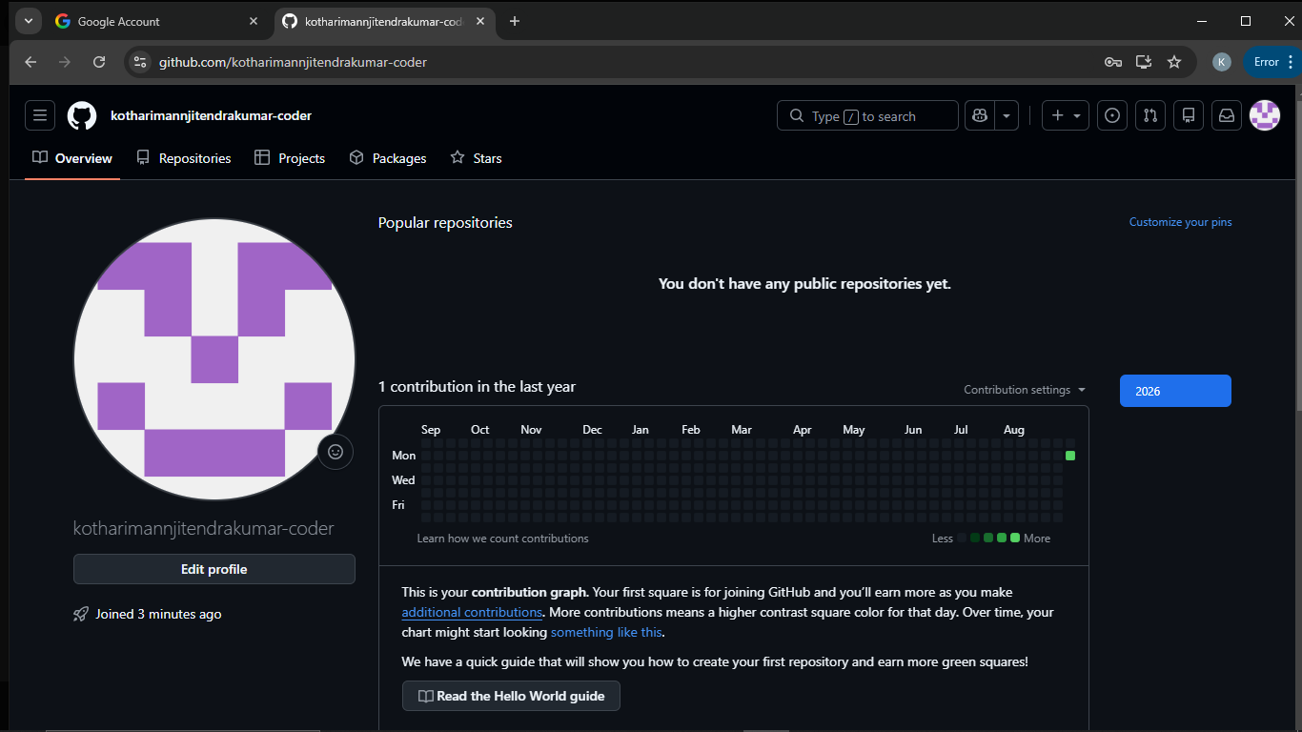
Defect ID | N/A

TC06 – Verify Logout functionality
TC ID | TC06
Test Case | Verify Logout functionality
Test Data | Signed-in account
Expected Result | User is signed out and the GitHub home / sign-in page is displayed
Actual Result | Signed out; GitHub home / sign-in page displayed
Status | PASS
Screenshot
Defect ID | N/A

Additional Report: SDLC / STLC Diagram
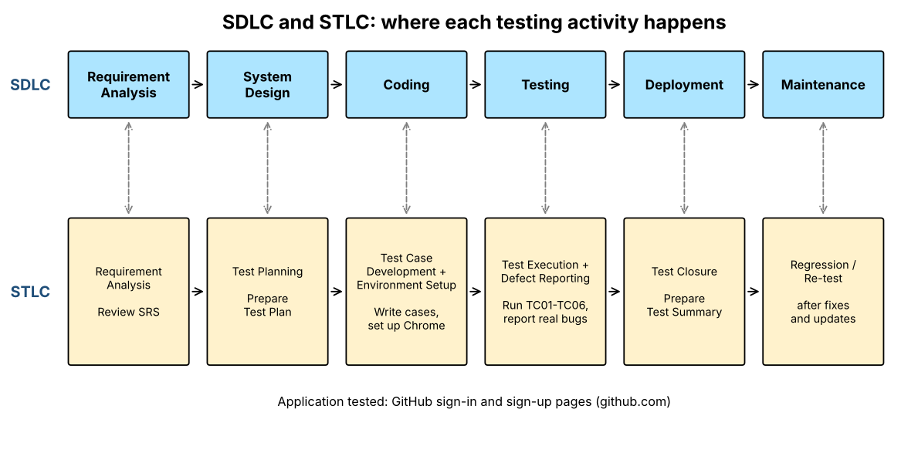

SDLC Phases and Activities
SDLC Phase | Activity
Requirement Analysis | Collect user requirements
System Design | Design UI and Database
Coding | Develop Login Module
Testing | Verify Login functionality
Deployment | Install software
Maintenance | Fix bugs and update software

STLC Phases and Activities
STLC Phase | Activity
Requirement Analysis | Review SRS
Test Planning | Prepare Test Plan
Test Case Development | Write Test Cases
Test Environment Setup | Configure system
Test Execution | Execute test cases
Defect Reporting | Report bugs
Test Closure | Prepare Test Summary

Where each testing activity occurs (this practical)
SDLC Phase | STLC Phase | Testing Activity in this practical | Deliverable
Requirement Analysis | Requirement Analysis | Study the Login and Sign-up requirements of the website | Requirement notes
System Design | Test Planning | Decide what to test: login page, sign-up page, fields, login, logout | Test plan (scope)
Coding | Test Case Development | Write test cases TC01-TC06 in the sheet | Test case sheet
Coding | Test Environment Setup | Windows + Google Chrome + internet | Environment ready
Testing | Test Execution | Execute TC01-TC06 and capture screenshots | Screenshot report
Testing | Defect Reporting | Report only real defects (none for the page behaviour seen) | Bug report (if any)
Deployment | Test Closure | Prepare the test execution summary | Summary
Maintenance | Regression / re-test | Re-run the tests after fixes or updates | Updated results

Test Execution Summary
Metric | Value
Total Test Cases | 6
Passed | 6
Failed | 0
Blocked | 0
Not executed yet (fill after running) | 0
Pass % | 100.0%

